# **Exercise 1: ( 10 minutes )**

**Instruction 1:**

# **Text generation for the desired context**

**Step 1:** Follow the [How to Use ChatGPT](https://docs.google.com/document/d/1yYpxUxap0-evWTdL1uEjxOEoTZayTlBKX_MQwjbs9D0/edit#heading=h.u17hwjcifzpk) to create an open chat account first if not created already.

**Step 2:** Now go to chatgpt.com and click New Chat

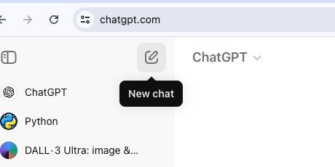

**Step 3:** Name the chat: Use the pencil icon available on the top-left corner of the right pane to name the chat.

**Step 4 :** Choose the model . ( In free account you will have access to GPT 3.5 and limited access to GPT 4-o)

**Step 5:** Give prompt instructions: Use the Prompt field on the lower right pane of the chat system to provide instructions or any specific details about the context of the required output.

**Step 6:** Type your message: Use the text box available at the bottom of the page to write the prompts and converse with the chat system.

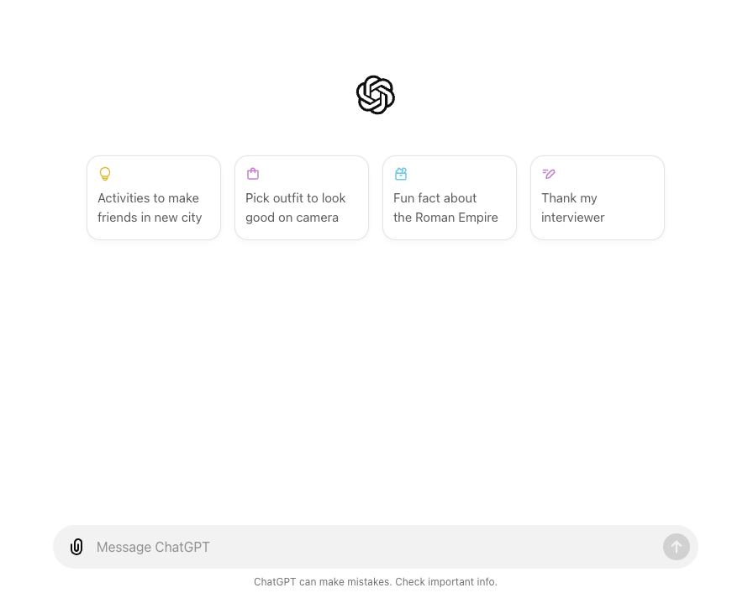

**Step 7:** Type your message: Use the text box available at the bottom of the page to write the prompts and converse with the chat system.

**Instruction 2:**

## **Generate text using a text prompt or scenario**

Think of a context and draft a statement or prompt for the desired text content you want from the chatbot. For better results, include specifics and details about the context of the required output.

1. Write your prompt or statement in the Type your message field at the bottom of the screen.  
   For example,  
     
   **Write a short poem about the moon.**You will see the textual response with the desired content in the middle pane on the right side of the screen**.**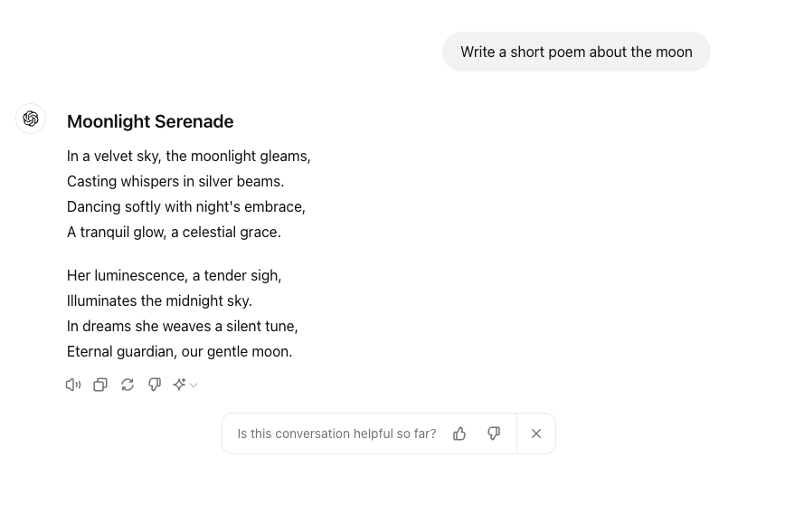

1. If you are unsatisfied with the response, click Regenerate button, and the chat system will show a revised response for your original prompt.

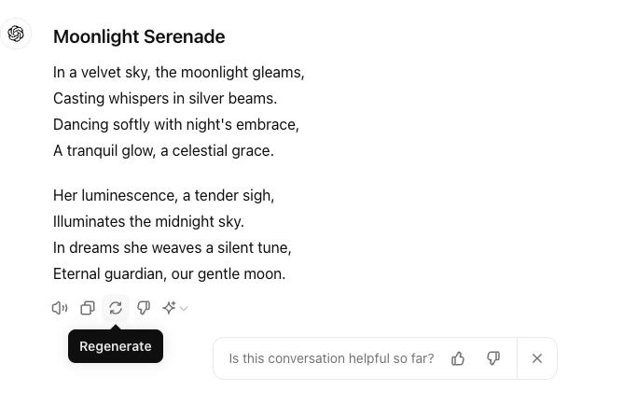

## 

## **Instruction 3**

## **Convert generated text into different text formats**

You can also test the conversational capabilities of the language model.

1. Continue with the same Step 2 example in the same chat window.
2. Enter the additional prompt in the Start chat field to convert the generated text into a different text format.

For example,

* **Convert this poem into a short story.**

